**Nama : Bayu Prasetya Adji Sugiyarto**

**NIM : A11.2019.11688**

**Pertemuan : 5**

**Kelompok : A11.4304**

MaterialMe!

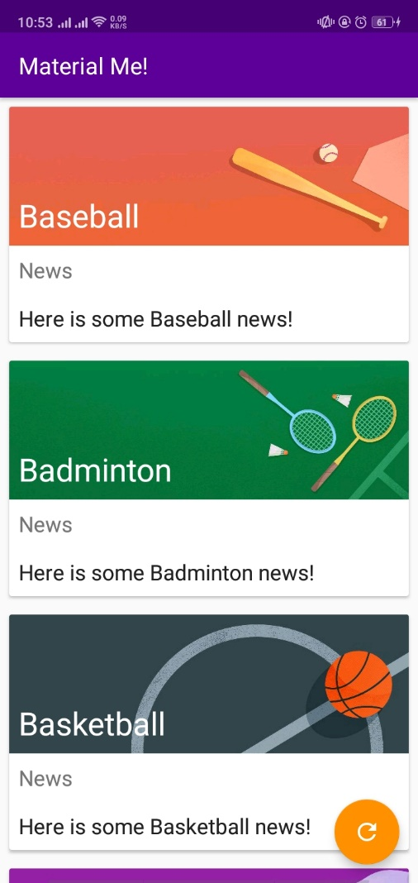

String.xml

<**resources**>  
 <**string name="app_name"**>Material Me!</**string**>  
 <**string name="title_placeholder"**>Title</**string**>  
 <**string name="news_label"**>News</**string**>  
 <**string name="sports_info_placeholder"**>Here is some news</**string**>  
 <**string name="sports_image"**>Sports Image</**string**>  
 <**string name="filler_text"**>Lorem ipsum dolor sit amet, consectetur adipiscing elit. Maecenas  
 vitae semper quam. In a metus ut nisl pharetra hendrerit et a leo. Curabitur nec sapien  
 odio. Vestibulum a mollis felis. Cras molestie felis nibh, ut maximus mauris feugiat  
 tincidunt. Curabitur ultricies eros sed ipsum pulvinar vehicula. Maecenas volutpat,  
 massa sit amet aliquam eleifend, massa lorem tempor sapien, eget finibus massa dolor  
 molestie lorem. Suspendisse at purus mauris. Proin nibh ligula, suscipit vel pharetra  
 posuere, bibendum id lorem.</**string**>  
  
 <**string-array name="sports_titles"**>  
 <**item**>Baseball</**item**>  
 <**item**>Badminton</**item**>  
 <**item**>Basketball</**item**>  
 <**item**>Bowling</**item**>  
 <**item**>Cycling</**item**>  
 <**item**>Golf</**item**>  
 <**item**>Running</**item**>  
 <**item**>Soccer</**item**>  
 <**item**>Swimming</**item**>  
 <**item**>Table Tennis</**item**>  
 <**item**>Tennis</**item**>  
 </**string-array**>  
  
 <**string-array name="sports_info"**>  
 <**item**>Here is some Baseball news!</**item**>  
 <**item**>Here is some Badminton news!</**item**>  
 <**item**>Here is some Basketball news!</**item**>  
 <**item**>Here is some Bowling news!</**item**>  
 <**item**>Here is some Cycling news!</**item**>  
 <**item**>Here is some Golf news!</**item**>  
 <**item**>Here is some Running news!</**item**>  
 <**item**>Here is some Soccer news!</**item**>  
 <**item**>Here is some Swimming news!</**item**>  
 <**item**>Here is some Table Tennis news!</**item**>  
 <**item**>Here is some Tennis news!</**item**>  
 </**string-array**>  
  
 <**array name="sports_images"**>  
 <**item**>@drawable/img_baseball</**item**>  
 <**item**>@drawable/img_badminton</**item**>  
 <**item**>@drawable/img_basketball</**item**>  
 <**item**>@drawable/img_bowling</**item**>  
 <**item**>@drawable/img_cycling</**item**>  
 <**item**>@drawable/img_golf</**item**>  
 <**item**>@drawable/img_running</**item**>  
 <**item**>@drawable/img_soccer</**item**>  
 <**item**>@drawable/img_swimming</**item**>  
 <**item**>@drawable/img_tabletennis</**item**>  
 <**item**>@drawable/img_tennis</**item**>  
 </**array**>  
  
</**resources**>

Mainactivity.java

**package** com.example.android.materialme;  
  
**import** android.content.res.TypedArray;  
**import** android.os.Bundle;  
**import** android.support.v7.app.AppCompatActivity;  
**import** android.support.v7.widget.LinearLayoutManager;  
**import** android.support.v7.widget.RecyclerView;  
**import** android.support.v7.widget.helper.ItemTouchHelper;  
**import** android.view.View;  
  
**import** java.util.ArrayList;  
**import** java.util.Collections;  
  
  
**public class** MainActivity **extends** AppCompatActivity {  
  
 *//Member variables* **private** RecyclerView **mRecyclerView**;  
 **private** ArrayList<Sport> **mSportsData**;  
 **private** SportsAdapter **mAdapter**;  
  
 @Override  
 **protected void** onCreate(Bundle savedInstanceState) {  
 **super**.onCreate(savedInstanceState);  
 setContentView(R.layout.***activity_main***);  
  
 *//Initialize the RecyclerView* **mRecyclerView** = (RecyclerView)findViewById(R.id.***recyclerView***);  
  
 *//Set the Layout Manager* **mRecyclerView**.setLayoutManager(**new** LinearLayoutManager(**this**));  
  
  
 *//Initialize the ArrayList that will contain the data* **mSportsData** = **new** ArrayList<>();  
  
 *//Initialize the adapter and set it ot the RecyclerView* **mAdapter** = **new** SportsAdapter(**this**, **mSportsData**);  
 **mRecyclerView**.setAdapter(**mAdapter**);  
  
 *//Get the data* initializeData();  
  
 *//Helper class for creating swipe to dismiss and drag and drop functionality* ItemTouchHelper helper = **new** ItemTouchHelper(**new** ItemTouchHelper.SimpleCallback  
 (ItemTouchHelper.***LEFT*** | ItemTouchHelper.***RIGHT*** | ItemTouchHelper.***DOWN*** | ItemTouchHelper.***UP***, ItemTouchHelper.***LEFT*** | ItemTouchHelper.***RIGHT***) {  
  
  
 @Override  
 **public boolean** onMove(RecyclerView recyclerView, RecyclerView.ViewHolder viewHolder,  
 RecyclerView.ViewHolder target) {  
  
 *//Get the from and to position* **int** from = viewHolder.getAdapterPosition();  
 **int** to = target.getAdapterPosition();  
  
 *//Swap the items and notify the adapter* Collections.*swap*(**mSportsData**, from, to);  
 **mAdapter**.notifyItemMoved(from, to);  
 **return true**;  
 }  
   
 @Override  
 **public void** onSwiped(RecyclerView.ViewHolder viewHolder, **int** direction) {  
  
 *//Remove the item from the dataset* **mSportsData**.remove(viewHolder.getAdapterPosition());  
  
 *//Notify the adapter* **mAdapter**.notifyItemRemoved(viewHolder.getAdapterPosition());  
 }  
 });  
  
 *//Attach the helper to the RecyclerView* helper.attachToRecyclerView(**mRecyclerView**);  
 }  
  
 */**  
 * Method for initializing the sports data from resources.  
 */* **private void** initializeData() {  
 *//Get the resources from the XML file* String[] sportsList = getResources().getStringArray(R.array.***sports_titles***);  
 String[] sportsInfo = getResources().getStringArray(R.array.***sports_info***);  
 TypedArray sportsImageResources = getResources().obtainTypedArray(R.array.***sports_images***);  
 *//Clear the existing data (to avoid duplication)* **mSportsData**.clear();  
  
  
 *//Create the ArrayList of Sports objects with the titles, images  
 // and information about each sport* **for**(**int** i=0; i<sportsList.**length**; i++){  
 **mSportsData**.add(**new** Sport(sportsList[i], sportsInfo[i],  
 sportsImageResources.getResourceId(i,0)));  
 }  
  
 *//Recycle the typed array* sportsImageResources.recycle();  
  
 *//Notify the adapter of the change* **mAdapter**.notifyDataSetChanged();  
 }  
   
 **public void** resetSports(View view) {  
 initializeData();  
 }  
}

detailactivity.java

**package** com.example.android.materialme;  
  
**import** android.graphics.Color;  
**import** android.graphics.drawable.Drawable;  
**import** android.graphics.drawable.GradientDrawable;  
**import** android.os.Bundle;  
**import** android.support.v4.content.ContextCompat;  
**import** android.support.v7.app.AppCompatActivity;  
**import** android.widget.ImageView;  
**import** android.widget.TextView;  
  
**import** com.bumptech.glide.Glide;  
  
  
**public class** DetailActivity **extends** AppCompatActivity {  
   
 @Override  
 **protected void** onCreate(Bundle savedInstanceState) {  
 **super**.onCreate(savedInstanceState);  
 setContentView(R.layout.***activity_detail***);  
  
 *//Initialize the views* TextView sportsTitle = (TextView)findViewById(R.id.***titleDetail***);  
 ImageView sportsImage = (ImageView)findViewById(R.id.***sportsImageDetail***);  
  
 *//Get the drawable* Drawable drawable = ContextCompat.*getDrawable* (**this**,getIntent().getIntExtra(Sport.***IMAGE_KEY***, 0));  
  
 *//Create a placeholder gray scrim while the image loads* GradientDrawable gradientDrawable = **new** GradientDrawable();  
 gradientDrawable.setColor(Color.***GRAY***);  
  
 *//Make it the same size as the image* **if**(drawable!=**null**) {  
 gradientDrawable.setSize(drawable.getIntrinsicWidth(), drawable.getIntrinsicHeight());  
 }  
  
 *//Set the text from the Intent extra* sportsTitle.setText(getIntent().getStringExtra(Sport.***TITLE_KEY***));  
  
 *//Load the image using the glide library and the Intent extra* Glide.*with*(**this**).load(getIntent().getIntExtra(Sport.***IMAGE_KEY***,0))  
 .placeholder(gradientDrawable).into(sportsImage);  
 }  
}

sport.java

**package** com.example.android.materialme;  
  
**import** android.content.Context;  
**import** android.content.Intent;  
**import** android.support.annotation.DrawableRes;  
  
  
**class** Sport {  
  
 *//Member variables representing the title, image and information about the sport* **private final** String **title**;  
 **private final** String **info**;  
 **private final int imageResource**;  
  
 **static final** String ***TITLE_KEY*** = **"Title"**;  
 **static final** String ***IMAGE_KEY*** = **"Image Resource"**;  
   
 Sport(String title, String info, **int** imageResource) {  
 **this**.**title** = title;  
 **this**.**info** = info;  
 **this**.**imageResource** = imageResource;  
 }  
  
  
 String getTitle() {  
 **return title**;  
 }  
  
 String getInfo() {  
 **return info**;  
 }  
   
 **int** getImageResource() {  
 **return imageResource**;  
 }  
  
  
 **static** Intent starter(Context context, String title, @DrawableRes **int** imageResId) {  
 Intent detailIntent = **new** Intent(context, DetailActivity.**class**);  
 detailIntent.putExtra(***TITLE_KEY***, title);  
 detailIntent.putExtra(***IMAGE_KEY***, imageResId);  
 **return** detailIntent;  
 }  
}

sportAdapter.java

**package** com.example.android.materialme;  
  
**import** android.content.Context;  
**import** android.content.Intent;  
**import** android.graphics.Color;  
**import** android.graphics.drawable.Drawable;  
**import** android.graphics.drawable.GradientDrawable;  
**import** android.support.v4.content.ContextCompat;  
**import** android.support.v7.widget.RecyclerView;  
**import** android.view.LayoutInflater;  
**import** android.view.View;  
**import** android.view.ViewGroup;  
**import** android.widget.ImageView;  
**import** android.widget.TextView;  
  
**import** com.bumptech.glide.Glide;  
  
**import** java.util.ArrayList;  
  
  
**class** SportsAdapter **extends** RecyclerView.Adapter<SportsAdapter.SportsViewHolder> {  
  
 *//Member variables* **private** GradientDrawable **mGradientDrawable**;  
 **private** ArrayList<Sport> **mSportsData**;  
 **private** Context **mContext**;  
  
  
 SportsAdapter(Context context, ArrayList<Sport> sportsData) {  
 **this**.**mSportsData** = sportsData;  
 **this**.**mContext** = context;  
  
 *//Prepare gray placeholder* **mGradientDrawable** = **new** GradientDrawable();  
 **mGradientDrawable**.setColor(Color.***GRAY***);  
  
 *//Make the placeholder same size as the images* Drawable drawable = ContextCompat.*getDrawable* (**mContext**,R.drawable.***img_badminton***);  
 **if**(drawable != **null**) {  
 **mGradientDrawable**.setSize(drawable.getIntrinsicWidth(), drawable.getIntrinsicHeight());  
 }  
 }  
  
   
 @Override  
 **public** SportsViewHolder onCreateViewHolder(ViewGroup parent, **int** viewType) {  
 **return new** SportsViewHolder(**mContext**, LayoutInflater.*from*(**mContext**).  
 inflate(R.layout.***list_item***, parent, **false**), **mGradientDrawable**);  
 }  
   
 @Override  
 **public void** onBindViewHolder(SportsViewHolder holder, **int** position) {  
  
 *//Get the current sport* Sport currentSport = **mSportsData**.get(position);  
  
 *//Bind the data to the views* holder.bindTo(currentSport);  
  
 }  
  
  
 @Override  
 **public int** getItemCount() {  
 **return mSportsData**.size();  
 }  
  
   
 **static class** SportsViewHolder **extends** RecyclerView.ViewHolder  
 **implements** View.OnClickListener {  
  
 *//Member Variables for the holder data* **private** TextView **mTitleText**;  
 **private** TextView **mInfoText**;  
 **private** ImageView **mSportsImage**;  
 **private** Context **mContext**;  
 **private** Sport **mCurrentSport**;  
 **private** GradientDrawable **mGradientDrawable**;  
   
 SportsViewHolder(Context context, View itemView, GradientDrawable gradientDrawable) {  
 **super**(itemView);  
  
 *//Initialize the views* **mTitleText** = (TextView)itemView.findViewById(R.id.***title***);  
 **mInfoText** = (TextView)itemView.findViewById(R.id.***subTitle***);  
 **mSportsImage** = (ImageView)itemView.findViewById(R.id.***sportsImage***);  
  
 **mContext** = context;  
 **mGradientDrawable** = gradientDrawable;  
  
 *//Set the OnClickListener to the whole view* itemView.setOnClickListener(**this**);  
 }  
  
 **void** bindTo(Sport currentSport){  
 *//Populate the textviews with data* **mTitleText**.setText(currentSport.getTitle());  
 **mInfoText**.setText(currentSport.getInfo());  
  
 *//Get the current sport* **mCurrentSport** = currentSport;  
  
  
  
 *//Load the images into the ImageView using the Glide library* Glide.*with*(**mContext**).load(currentSport.  
 getImageResource()).placeholder(**mGradientDrawable**).into(**mSportsImage**);  
 }  
  
 @Override  
 **public void** onClick(View view) {  
  
 *//Set up the detail intent* Intent detailIntent = Sport.*starter*(**mContext**, **mCurrentSport**.getTitle(),  
 **mCurrentSport**.getImageResource());  
  
  
 *//Start the detail activity* **mContext**.startActivity(detailIntent);  
 }  
 }  
}

activity_main.xml<**FrameLayout xmlns:android="http://schemas.android.com/apk/res/android"  
 xmlns:tools="http://schemas.android.com/tools"  
 android:layout_width="match_parent"  
 android:layout_height="match_parent"  
 tools:context="com.example.android.materialme.MainActivity"**>  
  
 <**android.support.v7.widget.RecyclerView  
 android:id="@+id/recyclerView"  
 android:scrollbars="vertical"  
 android:layout_width="match_parent"  
 android:layout_height="match_parent"** />  
  
 <**android.support.design.widget.FloatingActionButton  
 android:layout_width="wrap_content"  
 android:layout_height="wrap_content"  
 android:layout_gravity="bottom|end|right"  
 android:layout_margin="@dimen/activity_horizontal_margin"  
 android:src="@drawable/ic_reset"  
 android:tint="@android:color/white"  
 android:onClick="resetSports"**/>  
  
</**FrameLayout**>

Activity_detail.xml

<**FrameLayout xmlns:android="http://schemas.android.com/apk/res/android"  
 xmlns:tools="http://schemas.android.com/tools"  
 android:layout_width="match_parent"  
 android:layout_height="match_parent"  
 tools:context="com.example.android.materialme.MainActivity"**>  
  
 <**android.support.v7.widget.RecyclerView  
 android:id="@+id/recyclerView"  
 android:scrollbars="vertical"  
 android:layout_width="match_parent"  
 android:layout_height="match_parent"** />  
  
 <**android.support.design.widget.FloatingActionButton  
 android:layout_width="wrap_content"  
 android:layout_height="wrap_content"  
 android:layout_gravity="bottom|end|right"  
 android:layout_margin="@dimen/activity_horizontal_margin"  
 android:src="@drawable/ic_reset"  
 android:tint="@android:color/white"  
 android:onClick="resetSports"**/>  
  
</**FrameLayout**>

List_item.xml

<**android.support.v7.widget.CardView xmlns:android="http://schemas.android.com/apk/res/android"  
 android:layout_width="match_parent"  
 android:layout_height="wrap_content"  
 android:layout_margin="@dimen/card_margin"  
 android:background="?android:selectableItemBackground"**>  
  
 <**RelativeLayout  
 android:layout_width="match_parent"  
 android:layout_height="wrap_content"**>  
  
 <**ImageView  
 android:id="@+id/sportsImage"  
 android:layout_width="match_parent"  
 android:layout_height="wrap_content"  
 android:adjustViewBounds="true"**/>  
  
 <**TextView  
 android:id="@+id/title"  
 style="@style/TextAppearance.AppCompat.Headline"  
 android:layout_width="wrap_content"  
 android:layout_height="wrap_content"  
 android:layout_alignBottom="@id/sportsImage"  
 android:padding="@dimen/card_margin"  
 android:text="@string/title_placeholder"  
 android:theme="@style/ThemeOverlay.AppCompat.Dark"**/>  
  
 <**TextView  
 android:id="@+id/newsTitle"  
 style="@style/TextAppearance.AppCompat.Subhead"  
 android:layout_width="wrap_content"  
 android:layout_height="wrap_content"  
 android:layout_below="@id/sportsImage"  
 android:padding="@dimen/card_margin"  
 android:text="@string/news_label"  
 android:textColor="?android:textColorSecondary"** />  
  
 <**TextView  
 android:id="@+id/subTitle"  
 style="@style/TextAppearance.AppCompat.Subhead"  
 android:layout_width="wrap_content"  
 android:layout_height="wrap_content"  
 android:layout_below="@id/newsTitle"  
 android:padding="@dimen/card_margin"  
 android:text="@string/sports_info_placeholder"** />  
 </**RelativeLayout**>  
</**android.support.v7.widget.CardView**>

SimpleAsyncTask

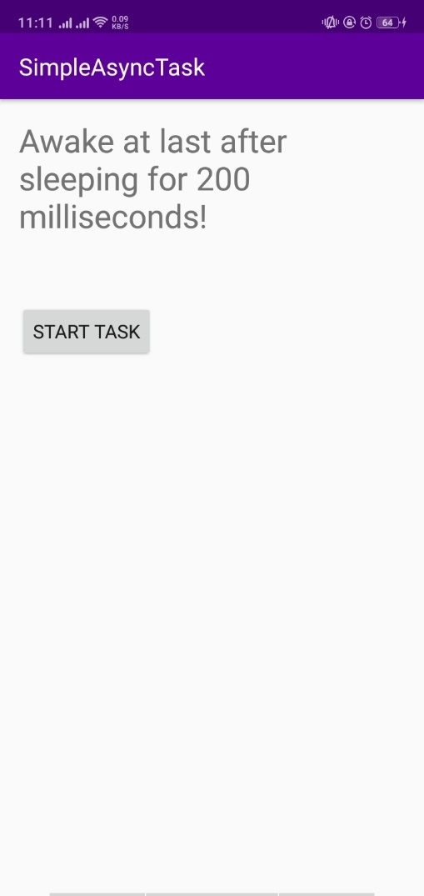

String.xml

<**resources**>  
 <**string name="app_name"**>SimpleAsyncTask</**string**>  
 <**string name="ready_to_start"**>I am ready to start work!</**string**>  
 <**string name="start_task"**>Start Task</**string**>  
 <**string name="napping"**>"Napping…"</**string**>  
</**resources**>

MainActivity.java

**package** android.example.com.simpleasynctask;  
  
**import** android.os.Bundle;  
**import** android.support.v7.app.AppCompatActivity;  
**import** android.view.View;  
**import** android.widget.TextView;  
  
**public class** MainActivity **extends** AppCompatActivity {  
  
 *//Key for saving the state of the TextView* **private static final** String ***TEXT_STATE*** = **"currentText"**;  
  
 *// The TextView where we will show results* **private** TextView **mTextView**;  
  
 @Override  
 **protected void** onCreate(Bundle savedInstanceState) {  
 **super**.onCreate(savedInstanceState);  
 setContentView(R.layout.***activity_main***);  
 *// Initialize mTextView* **mTextView** = (TextView) findViewById(R.id.***textView1***);  
  
 *// Restore TextView if there is a savedInstanceState* **if**(savedInstanceState!=**null**){  
 **mTextView**.setText(savedInstanceState.getString(***TEXT_STATE***));  
 }  
 }  
  
 **public void** startTask (View view) {  
 *// Put a message in the text view* **mTextView**.setText(R.string.***napping***);  
  
 *// Start the AsyncTask.  
 // The AsyncTask has a callback that will update the text view.* **new** SimpleAsyncTask(**mTextView**).execute();  
 }  
  
  
 @Override  
 **protected void** onSaveInstanceState(Bundle outState) {  
 **super**.onSaveInstanceState(outState);  
 *// Save the state of the TextView* outState.putString(***TEXT_STATE***, **mTextView**.getText().toString());  
 }  
}

SimpleAsyncTask.java

**package** android.example.com.simpleasynctask;  
  
**import** android.os.AsyncTask;  
**import** android.widget.TextView;  
  
**import** java.util.Random;  
  
**class** SimpleAsyncTask **extends** AsyncTask<Void, Void, String> {  
  
 *// The TextView where we will show results* **private** TextView **mTextView**;  
  
 *// Constructor that provides a reference to the TextView from the MainActivity* **public** SimpleAsyncTask(TextView tv) {  
 **mTextView** = tv;  
 }  
  
 @Override  
 **protected** String doInBackground(Void... voids) {  
  
 *// Generate a random number between 0 and 10* Random r = **new** Random();  
 **int** n = r.nextInt(11);  
  
 *// Make the task take long enough that we have  
 // time to rotate the phone while it is running* **int** s = n * 200;  
  
 *// Sleep for the random amount of time* **try** {  
 Thread.*sleep*(s);  
 } **catch** (InterruptedException e) {  
 e.printStackTrace();  
 }  
  
 *// Return a String result* **return "Awake at last after sleeping for "** + s + **" milliseconds!"**;  
 }  
   
 **protected void** onPostExecute(String result) {  
 **mTextView**.setText(result);  
 }  
}

activity_main.xml

<**LinearLayout xmlns:android="http://schemas.android.com/apk/res/android"  
 android:layout_width="match_parent"  
 android:layout_height="match_parent"  
 android:paddingLeft="@dimen/activity_horizontal_margin"  
 android:paddingRight="@dimen/activity_horizontal_margin"  
 android:paddingTop="@dimen/activity_vertical_margin"  
 android:paddingBottom="@dimen/activity_vertical_margin"  
 android:orientation="vertical"**>  
  
 <**TextView  
 android:layout_width="wrap_content"  
 android:layout_height="wrap_content"  
 android:text="@string/ready_to_start"  
 android:id = "@+id/textView1"  
 android:textSize="24sp"**/>  
  
 <**Button  
 android:layout_width="wrap_content"  
 android:layout_height="wrap_content"  
 android:text="@string/start_task"  
 android:id="@+id/button"  
 android:layout_marginTop="56dp"  
 android:onClick="startTask"** />  
</**LinearLayout**>

WhoWroteIt

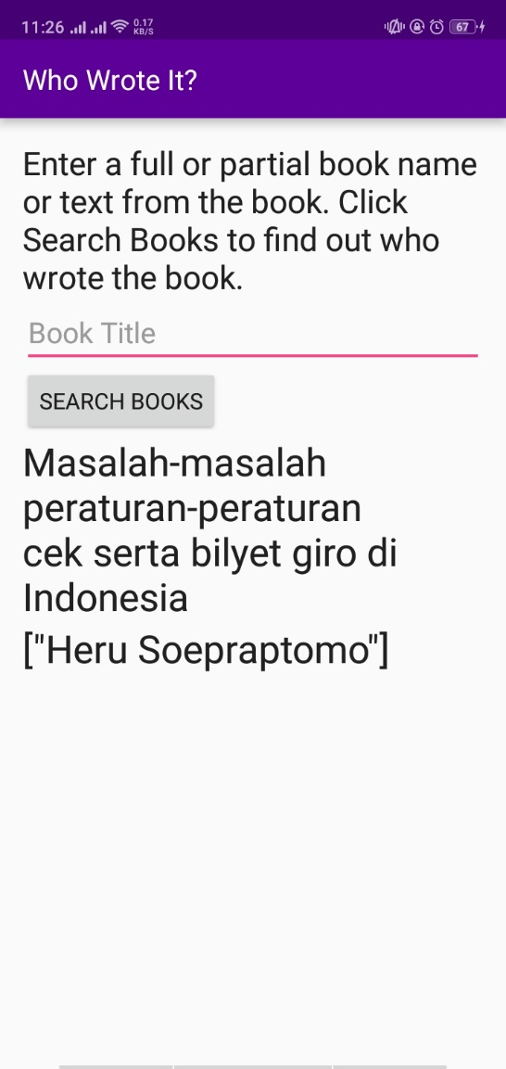

String.xml

<**resources**>  
 <**string name="app_name"**>Who Wrote It?</**string**>  
 <**string name="instructions"**>Enter a full or partial book name or text from the book. Click Search Books to find out who wrote the book. </**string**>  
 <**string name="button_text"**>Search Books</**string**>  
 <**string name="input_hint"**>Book Title</**string**>  
 <**string name="no_search_term"**>Please enter a search term</**string**>  
 <**string name="no_network"**>Please check your network connection and try again.</**string**>  
 <**string name="no_results"**>No Results Found</**string**>  
</**resources**>

Mainactivity.java

**package** com.example.android.whowroteit;  
  
**import** android.content.Context;  
**import** android.net.ConnectivityManager;  
**import** android.net.NetworkInfo;  
**import** android.os.Bundle;  
**import** android.support.v7.app.AppCompatActivity;  
**import** android.view.View;  
**import** android.view.inputmethod.InputMethodManager;  
**import** android.widget.EditText;  
**import** android.widget.TextView;  
  
**public class** MainActivity **extends** AppCompatActivity {  
  
 *// Variables for the search input field, and results TextViews.* **private** EditText **mBookInput**;  
 **private** TextView **mTitleText**;  
 **private** TextView **mAuthorText**;  
  
   
 @Override  
 **protected void** onCreate(Bundle savedInstanceState) {  
 **super**.onCreate(savedInstanceState);  
 setContentView(R.layout.***activity_main***);  
  
 *// Initialize all the view variables.* **mBookInput** = (EditText)findViewById(R.id.***bookInput***);  
 **mTitleText** = (TextView)findViewById(R.id.***titleText***);  
 **mAuthorText** = (TextView)findViewById(R.id.***authorText***);  
 }  
   
 **public void** searchBooks(View view) {  
 *// Get the search string from the input field.* String queryString = **mBookInput**.getText().toString();  
  
 *// Hide the keyboard when the button is pushed.* InputMethodManager inputManager = (InputMethodManager)  
 getSystemService(Context.***INPUT_METHOD_SERVICE***);  
 inputManager.hideSoftInputFromWindow(getCurrentFocus().getWindowToken(),  
 InputMethodManager.***HIDE_NOT_ALWAYS***);  
  
 *// Check the status of the network connection.* ConnectivityManager connMgr = (ConnectivityManager)  
 getSystemService(Context.***CONNECTIVITY_SERVICE***);  
 NetworkInfo networkInfo = connMgr.getActiveNetworkInfo();  
  
 *// If the network is active and the search field is not empty, start a FetchBook AsyncTask.* **if** (networkInfo != **null** && networkInfo.isConnected() && queryString.length()!=0) {  
 **new** FetchBook(**mTitleText**, **mAuthorText**, **mBookInput**).execute(queryString);  
 }  
 *// Otherwise update the TextView to tell the user there is no connection or no search term.* **else** {  
 **if** (queryString.length() == 0) {  
 **mAuthorText**.setText(**""**);  
 **mTitleText**.setText(R.string.***no_search_term***);  
 } **else** {  
 **mAuthorText**.setText(**""**);  
 **mTitleText**.setText(R.string.***no_network***);  
 }  
 }  
 }  
}

FetchBook.java

**package** com.example.android.whowroteit;  
  
**import** android.net.Uri;  
**import** android.os.AsyncTask;  
**import** android.widget.EditText;  
**import** android.widget.TextView;  
  
**import** org.json.JSONArray;  
**import** org.json.JSONObject;  
  
**import** java.io.BufferedReader;  
**import** java.io.IOException;  
**import** java.io.InputStream;  
**import** java.io.InputStreamReader;  
**import** java.net.HttpURLConnection;  
**import** java.net.URL;  
  
**public class** FetchBook **extends** AsyncTask<String,Void,String>{  
  
 *// Variables for the search input field, and results TextViews* **private** EditText **mBookInput**;  
 **private** TextView mTitleText;  
 **private** TextView **mAuthorText**;  
  
 *// Class name for Log tag* **private static final** String ***LOG_TAG*** = FetchBook.**class**.getSimpleName();  
  
 *// Constructor providing a reference to the views in MainActivity* **public** FetchBook(TextView titleText, TextView authorText, EditText bookInput) {  
 **this**.mTitleText = titleText;  
 **this**.**mAuthorText** = authorText;  
 **this**.**mBookInput** = bookInput;  
 }  
   
 @Override  
 **protected** String doInBackground(String... params) {  
  
 *// Get the search string* String queryString = params[0];  
  
  
 *// Set up variables for the try block that need to be closed in the finally block.* HttpURLConnection urlConnection = **null**;  
 BufferedReader reader = **null**;  
 String bookJSONString = **null**;  
  
 *// Attempt to query the Books API.* **try** {  
 *// Base URI for the Books API.* **final** String BOOK_BASE_URL = **"https://www.googleapis.com/books/v1/volumes?"**;  
  
 **final** String QUERY_PARAM = **"q"**; *// Parameter for the search string.* **final** String MAX_RESULTS = **"maxResults"**; *// Parameter that limits search results.* **final** String PRINT_TYPE = **"printType"**; *// Parameter to filter by print type.  
  
 // Build up your query URI, limiting results to 10 items and printed books.* Uri builtURI = Uri.*parse*(BOOK_BASE_URL).buildUpon()  
 .appendQueryParameter(QUERY_PARAM, queryString)  
 .appendQueryParameter(MAX_RESULTS, **"10"**)  
 .appendQueryParameter(PRINT_TYPE, **"books"**)  
 .build();  
  
 URL requestURL = **new** URL(builtURI.toString());  
  
 *// Open the network connection.* urlConnection = (HttpURLConnection) requestURL.openConnection();  
 urlConnection.setRequestMethod(**"GET"**);  
 urlConnection.connect();  
  
 *// Get the InputStream.* InputStream inputStream = urlConnection.getInputStream();  
  
 *// Read the response string into a StringBuilder.* StringBuilder builder = **new** StringBuilder();  
  
 reader = **new** BufferedReader(**new** InputStreamReader(inputStream));  
  
 String line;  
 **while** ((line = reader.readLine()) != **null**) {  
 *// Since it's JSON, adding a newline isn't necessary (it won't affect parsing)  
 // but it does make debugging a *lot* easier if you print out the completed buffer for debugging.* builder.append(line + **"\n"**);  
 }  
  
 **if** (builder.length() == 0) {  
 *// Stream was empty. No point in parsing.  
 // return null;* **return null**;  
 }  
 bookJSONString = builder.toString();  
  
 *// Catch errors.* } **catch** (IOException e) {  
 e.printStackTrace();  
  
 *// Close the connections.* } **finally** {  
 **if** (urlConnection != **null**) {  
 urlConnection.disconnect();  
 }  
 **if** (reader != **null**) {  
 **try** {  
 reader.close();  
 } **catch** (IOException e) {  
 e.printStackTrace();  
 }  
  
 }  
 }  
  
 *// Return the raw response.* **return** bookJSONString;  
 }  
   
 @Override  
 **protected void** onPostExecute(String s) {  
 **super**.onPostExecute(s);  
 **try** {  
 *// Convert the response into a JSON object.* JSONObject jsonObject = **new** JSONObject(s);  
 *// Get the JSONArray of book items.* JSONArray itemsArray = jsonObject.getJSONArray(**"items"**);  
  
 *// Initialize iterator and results fields.* **int** i = 0;  
 String title = **null**;  
 String authors = **null**;  
  
 *// Look for results in the items array, exiting when both the title and author  
 // are found or when all items have been checked.* **while** (i < itemsArray.length() || (authors == **null** && title == **null**)) {  
 *// Get the current item information.* JSONObject book = itemsArray.getJSONObject(i);  
 JSONObject volumeInfo = book.getJSONObject(**"volumeInfo"**);  
  
 *// Try to get the author and title from the current item,  
 // catch if either field is empty and move on.* **try** {  
 title = volumeInfo.getString(**"title"**);  
 authors = volumeInfo.getString(**"authors"**);  
 } **catch** (Exception e){  
 e.printStackTrace();  
 }  
  
 *// Move to the next item.* i++;  
 }  
  
 *// If both are found, display the result.* **if** (title != **null** && authors != **null**){  
 mTitleText.setText(title);  
 **mAuthorText**.setText(authors);  
 **mBookInput**.setText(**""**);  
 } **else** {  
 *// If none are found, update the UI to show failed results.* mTitleText.setText(R.string.***no_results***);  
 **mAuthorText**.setText(**""**);  
 }  
  
 } **catch** (Exception e){  
 *// If onPostExecute does not receive a proper JSON string,  
 // update the UI to show failed results.* mTitleText.setText(R.string.***no_results***);  
 **mAuthorText**.setText(**""**);  
 e.printStackTrace();  
 }  
 }  
}

activity_main.xml

*<?***xml version="1.0" encoding="utf-8"***?>*<**LinearLayout xmlns:android="http://schemas.android.com/apk/res/android"  
 xmlns:tools="http://schemas.android.com/tools"  
 android:layout_width="match_parent"  
 android:layout_height="match_parent"  
 android:paddingBottom="@dimen/activity_vertical_margin"  
 android:paddingLeft="@dimen/activity_horizontal_margin"  
 android:paddingRight="@dimen/activity_horizontal_margin"  
 android:paddingTop="@dimen/activity_vertical_margin"  
 android:orientation="vertical"  
 tools:context="com.example.android.whowroteit.MainActivity"**>  
  
 <**TextView  
 android:layout_width="wrap_content"  
 android:layout_height="wrap_content"  
 android:id="@+id/instructions"  
 android:text="@string/instructions"  
 android:textAppearance="@style/TextAppearance.AppCompat.Title"**/>  
  
 <**EditText  
 android:layout_width="match_parent"  
 android:layout_height="wrap_content"  
 android:id="@+id/bookInput"  
 android:inputType="text"  
 android:hint="@string/input_hint"**/>  
 <**Button  
 android:layout_width="wrap_content"  
 android:layout_height="wrap_content"  
 android:id="@+id/searchButton"  
 android:text="@string/button_text"  
 android:onClick="searchBooks"** />  
 <**TextView  
 android:layout_width="wrap_content"  
 android:layout_height="wrap_content"  
 android:id="@+id/titleText"  
 android:textAppearance="@style/TextAppearance.AppCompat.Headline"**/>  
 <**TextView  
 android:layout_width="wrap_content"  
 android:layout_height="wrap_content"  
 android:id="@+id/authorText"  
 android:textAppearance="@style/TextAppearance.AppCompat.Headline"**/>  
</**LinearLayout**>

PowerReciever

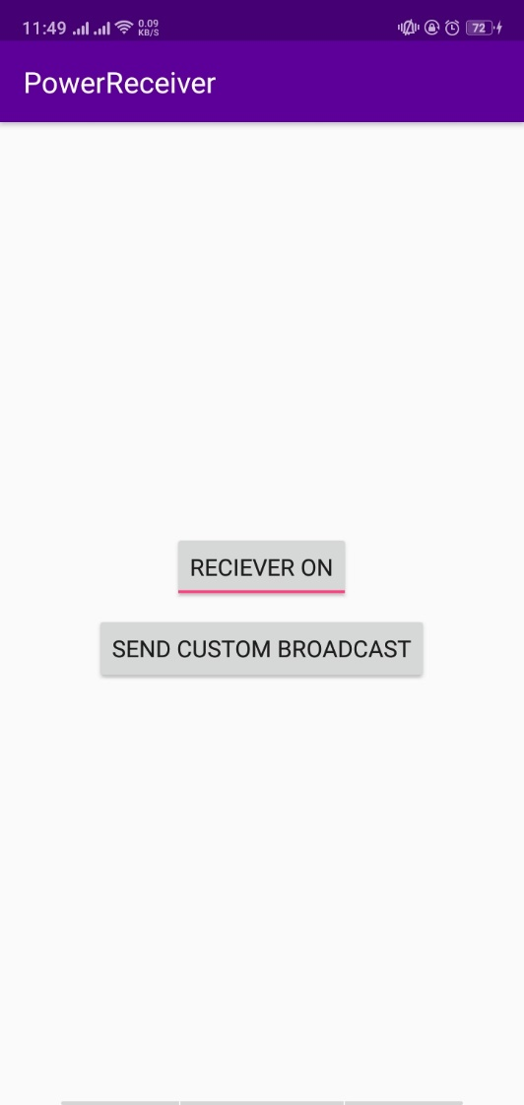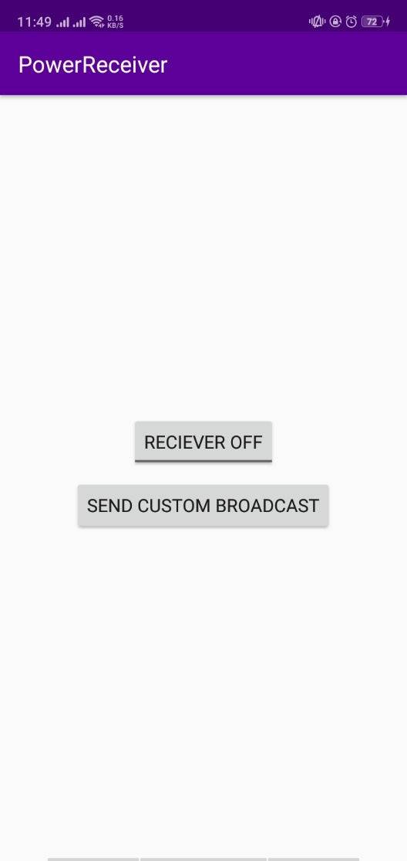

Stirng.xml

<**resources**>  
 <**string name="app_name"**>PowerReceiver</**string**>  
 <**string name="power_connected"**>Power connected!</**string**>  
 <**string name="power_disconnected"**>Power disconnected!</**string**>  
 <**string name="custom_broadcast_toast"**>Custom Broadcast Received</**string**>  
 <**string name="send_custom_broadcast"**>Send Custom Broadcast</**string**>  
 <**string name="receiver_on"**>Receiver On</**string**>  
 <**string name="receiver_off"**>Receiver Off</**string**>  
</**resources**>

Mainactivity.java

**package** com.example.android.powerreceiver;  
  
**import** android.content.ComponentName;  
**import** android.content.Intent;  
**import** android.content.IntentFilter;  
**import** android.content.pm.PackageManager;  
**import** android.os.Bundle;  
**import** android.support.v4.content.LocalBroadcastManager;  
**import** android.support.v7.app.AppCompatActivity;  
**import** android.view.View;  
**import** android.widget.Button;  
**import** android.widget.CompoundButton;  
**import** android.widget.ToggleButton;  
  
**import** java.util.function.ToLongBiFunction;  
  
**public class** MainActivity **extends** AppCompatActivity {  
  
 **private** CustomReceiver **mReceiver** = **new** CustomReceiver();  
 **private** ComponentName **mReceiverComponentName**;  
 **private** PackageManager **mPackageManager**;  
  
 @Override  
 **protected void** onCreate(Bundle savedInstanceState) {  
 **super**.onCreate(savedInstanceState);  
 setContentView(R.layout.***activity_main***);  
  
 Button broadcastButton = (Button) findViewById(R.id.***broadcastButton***);  
  
 *//Get the PackageManager and ComponentName so you can toggle to broadcast receiver.* **mReceiverComponentName** = **new** ComponentName(**this**, CustomReceiver.**class**);  
 **mPackageManager** = getPackageManager();  
  
 *//Use LocalBroadcastManager so that the broadcast is not received by other applications.* LocalBroadcastManager.*getInstance*(**this**).registerReceiver  
 (**mReceiver**, **new** IntentFilter(CustomReceiver.***ACTION_CUSTOM_BROADCAST***));  
  
 *//onClick method for the button* broadcastButton.setOnClickListener(**new** View.OnClickListener() {  
 @Override  
 **public void** onClick(View view) {  
 sendCustomBroadcast();  
 }  
 });  
  
 ToggleButton Simpletogglebutton = (ToggleButton) findViewById(R.id.***tbutton***);  
 Simpletogglebutton.setText(**"Reciever Off"**);  
 Simpletogglebutton.setTextOn(**"Reciever On"**);  
 Simpletogglebutton.setTextOff(**"Reciever Off"**);  
  
 Simpletogglebutton.setOnCheckedChangeListener(**new** CompoundButton.OnCheckedChangeListener() {  
 @Override  
 **public void** onCheckedChanged(CompoundButton buttonView, **boolean** isChecked) {  
 **if** (isChecked) {  
 onStart();  
 }**else** {  
 onStop();  
 }  
 }  
 });  
  
 }  
  
  
 @Override  
 **protected void** onStart() {  
 *//Enable the broadcast receiver when the app is visible* **mPackageManager**.setComponentEnabledSetting  
 (**mReceiverComponentName**, PackageManager.***COMPONENT_ENABLED_STATE_ENABLED***,  
 PackageManager.***DONT_KILL_APP***);  
 **super**.onStart();  
 }  
  
 @Override  
 **protected void** onStop() {  
 *//Disable the broadcast receiver when the app is visible* **mPackageManager**.setComponentEnabledSetting  
 (**mReceiverComponentName**, PackageManager.***COMPONENT_ENABLED_STATE_DISABLED***,  
 PackageManager.***DONT_KILL_APP***);  
 **super**.onStop();  
 }  
  
 @Override  
 **protected void** onDestroy() {  
 LocalBroadcastManager.*getInstance*(**this**).unregisterReceiver(**mReceiver**);  
 **super**.onDestroy();  
 }  
  
 **private void** sendCustomBroadcast() {  
 Intent customBroadcastIntent = **new** Intent(CustomReceiver.***ACTION_CUSTOM_BROADCAST***);  
 LocalBroadcastManager.*getInstance*(**this**).sendBroadcast(customBroadcastIntent);  
 }  
}

CustomReciever.java

**package** com.example.android.powerreceiver;  
  
**import** android.content.BroadcastReceiver;  
**import** android.content.Context;  
**import** android.content.Intent;  
**import** android.widget.Toast;  
  
  
**public class** CustomReceiver **extends** BroadcastReceiver {  
  
 *//String constant that defines the custom Broadcast Action* **static final** String ***ACTION_CUSTOM_BROADCAST*** =  
 **"com.example.android.powerreceiver.ACTION_CUSTOM_BROADCAST"**;  
  
  
 *//Empty constructor* **public** CustomReceiver() {  
 }  
  
   
 @Override  
 **public void** onReceive(Context context, Intent intent) {  
 String intentAction = intent.getAction();  
 String toastMessage = **null**;  
 **switch** (intentAction){  
 **case** Intent.***ACTION_POWER_CONNECTED***:  
 toastMessage = context.getString(R.string.***power_connected***);  
 **break**;  
 **case** Intent.***ACTION_POWER_DISCONNECTED***:  
 toastMessage = context.getString(R.string.***power_disconnected***);  
 **break**;  
 **case *ACTION_CUSTOM_BROADCAST***:  
 toastMessage = context.getString(R.string.***custom_broadcast_toast***);  
 **break**;  
 }  
  
 Toast.*makeText*(context, toastMessage, Toast.***LENGTH_SHORT***).show();  
 }  
  
}

activity_main.java

*<?***xml version="1.0" encoding="utf-8"***?>*<**LinearLayout xmlns:android="http://schemas.android.com/apk/res/android"  
 xmlns:tools="http://schemas.android.com/tools"  
 android:layout_width="match_parent"  
 android:layout_height="match_parent"  
 android:gravity="center"  
 android:orientation="vertical"  
 android:paddingBottom="@dimen/activity_vertical_margin"  
 android:paddingLeft="@dimen/activity_horizontal_margin"  
 android:paddingRight="@dimen/activity_horizontal_margin"  
 android:paddingTop="@dimen/activity_vertical_margin"  
 tools:context="com.example.android.powerreceiver.MainActivity"**>  
  
  
 <**Button  
 android:id="@+id/broadcastButton"  
 android:layout_width="wrap_content"  
 android:layout_height="wrap_content"  
 android:layout_margin="8dp"  
 android:text="@string/send_custom_broadcast"**/>  
</**LinearLayout**>

AyamKu

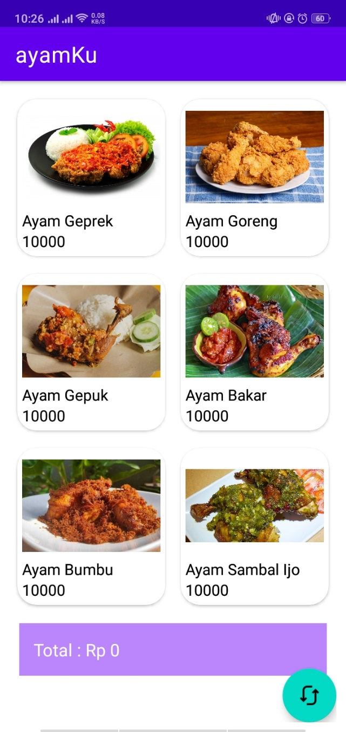

String.xml

<resources>  
 <string name="app_name">ayamKu</string>  
  
 <string-array name="title">  
 <item>Ayam Geprek</item>  
 <item>Ayam Goreng</item>  
 <item>Ayam Gepuk</item>  
 <item>Ayam Bakar</item>  
 <item>Ayam Bumbu</item>  
 <item>Ayam Sambal Ijo</item>  
 </string-array>  
  
 <string-array name="harga">  
 <item>10000</item>  
 <item>10000</item>  
 <item>10000</item>  
 <item>10000</item>  
 <item>10000</item>  
 <item>10000</item>  
 </string-array>  
  
 <string-array name="image">  
 <item>@drawable/ayamgeprek</item>  
 <item>@drawable/ayamgoreng</item>  
 <item>@drawable/ayamgepuk</item>  
 <item>@drawable/ayambakar</item>  
 <item>@drawable/ayambumbu</item>  
 <item>@drawable/ayamsambalijo</item>  
 </string-array>  
</resources>

Mainactivity.java

package com.example.ayamku;  
  
import androidx.annotation.NonNull;  
import androidx.appcompat.app.AppCompatActivity;  
import androidx.recyclerview.widget.GridLayoutManager;  
import androidx.recyclerview.widget.RecyclerView;  
  
import android.content.res.TypedArray;  
import android.os.Bundle;  
import android.view.MotionEvent;  
import android.view.View;  
import android.widget.TextView;  
  
import java.lang.reflect.Type;  
import java.util.ArrayList;  
  
public class MainActivity extends AppCompatActivity {  
 private RecyclerView recyclerView;  
 private ayamadapter adapter;  
 private ArrayList<ayam> ayamlist;  
 private int total = 0;  
 private TextView totalView;  
  
 @Override  
 protected void onCreate(Bundle savedInstanceState) {  
 super.onCreate(savedInstanceState);  
 setContentView(R.layout.*activity_main*);  
 ayamlist = new ArrayList<>();  
 totalView = (TextView) findViewById(R.id.*total*);  
 setTotal(0);  
 addData();  
  
 recyclerView = (RecyclerView) findViewById(R.id.*recycle_view*);  
 adapter = new ayamadapter(ayamlist);  
 RecyclerView.LayoutManager layoutManager = new GridLayoutManager(this,2);  
  
 recyclerView.setLayoutManager(layoutManager);  
 recyclerView.setAdapter(adapter);  
 recyclerView.addOnItemTouchListener(new RecyclerView.OnItemTouchListener() {  
 @Override  
 public boolean onInterceptTouchEvent(@NonNull RecyclerView rv, @NonNull MotionEvent e) {  
 TextView total = (TextView) rv.findViewById(R.id.*harga*);  
  
 setTotal(Integer.*valueOf*(String.*valueOf*(total.getText())));  
 return true;  
 }  
  
 @Override  
 public void onTouchEvent(@NonNull RecyclerView rv, @NonNull MotionEvent e) {  
  
 }  
  
 @Override  
 public void onRequestDisallowInterceptTouchEvent(boolean disallowIntercept) {  
  
 }  
 });  
 }  
  
 public void addData(){  
 String[] title_list = getResources().getStringArray(R.array.*title*);  
 String[] harga_list = getResources().getStringArray(R.array.*harga*);  
 TypedArray image_list = getResources().obtainTypedArray(R.array.*image*);  
  
 for (int i = 0; i < title_list.length; i++){  
 ayamlist.add(new ayam(title_list[i], harga_list[i], image_list.getResourceId(i, 0)));  
 }  
 }  
  
 public void setTotal(int total){  
 this.total = this.total + total;  
 totalView.setText("Total : Rp "+ String.*valueOf*(this.total));  
 }  
  
 public void reset (View view){  
 this.total = 0;  
 setTotal(0);  
 }  
}

ayam.java

package com.example.ayamku;  
  
public class ayam {  
 private String title;  
 private String harga;  
 private int image;  
  
 public ayam (String title, String harga, int image){  
 this.title = title;  
 this.harga = harga;  
 this.image = image;  
 }  
  
 public String getTitle(){  
 return title;  
 }  
  
 public String getHarga(){  
 return harga;  
 }  
  
 public int getImage(){  
 return image;  
 }  
  
  
}

ayamadapter.java

package com.example.ayamku;  
  
import android.text.Layout;  
import android.view.LayoutInflater;  
import android.view.View;  
import android.view.ViewGroup;  
import android.widget.ImageView;  
import android.widget.TextView;  
  
import androidx.annotation.NonNull;  
import androidx.recyclerview.widget.RecyclerView;  
  
import java.util.ArrayList;  
  
  
public class ayamadapter extends RecyclerView.Adapter<ayamadapter.AyamViewHolder> {  
  
 private ArrayList<ayam> dataList;  
 public ayamadapter(ArrayList<ayam> dataList){  
 this.dataList = dataList;  
 }  
 public static class AyamViewHolder extends RecyclerView.ViewHolder{  
 private TextView nama, price;  
 private TextView total;  
 private ImageView image;  
  
 public AyamViewHolder (View itemView){  
 super(itemView);  
 image = (ImageView) itemView.findViewById(R.id.*image*);  
 nama = (TextView) itemView.findViewById(R.id.*title*);  
 price = (TextView) itemView.findViewById(R.id.*harga*);  
 }  
 }  
 @NonNull  
 @Override  
 public AyamViewHolder onCreateViewHolder(@NonNull ViewGroup parent, int viewType){  
 LayoutInflater layoutInflater = LayoutInflater.*from*(parent.getContext());  
 View view = layoutInflater.inflate(R.layout.*list_item*, parent, false);  
 return new AyamViewHolder(view);  
 }  
 @Override  
 public int getItemCount(){  
  
 return (dataList != null) ? dataList.size():0;  
 }  
 @Override  
 public void onBindViewHolder(@NonNull ayamadapter.AyamViewHolder holder, int position){  
 holder.nama.setText(dataList.get(position).getTitle());  
 holder.price.setText(dataList.get(position).getHarga());  
 holder.image.setImageResource(dataList.get(position).getImage());  
 }  
  
  
}

activity_main.java

*<?*xml version="1.0" encoding="utf-8"*?>*<androidx.coordinatorlayout.widget.CoordinatorLayout xmlns:android="http://schemas.android.com/apk/res/android"  
 xmlns:app="http://schemas.android.com/apk/res-auto"  
 xmlns:tools="http://schemas.android.com/tools"  
 android:layout_width="match_parent"  
 android:layout_height="match_parent"  
 android:layout_marginHorizontal="10dp"  
 android:layout_marginVertical="10dp"  
 tools:context=".MainActivity">  
<ScrollView  
 android:layout_width="match_parent"  
 android:layout_height="match_parent">  
 <include layout="@layout/content_main"/>  
</ScrollView>  
  
 <com.google.android.material.floatingactionbutton.FloatingActionButton  
 android:id="@+id/reset"  
 android:layout_width="wrap_content"  
 android:layout_height="wrap_content"  
 android:layout_gravity="bottom|end"  
 android:onClick="reset"  
 android:src="@drawable/refresh"  
 />  
   
</androidx.coordinatorlayout.widget.CoordinatorLayout>

Content_main.xml

*<?*xml version="1.0" encoding="utf-8"*?>*<LinearLayout xmlns:android="http://schemas.android.com/apk/res/android"  
 android:layout_width="match_parent"  
 android:layout_height="match_parent"  
 android:orientation="vertical">  
  
 <androidx.recyclerview.widget.RecyclerView  
 android:id="@+id/recycle_view"  
 android:layout_width="match_parent"  
 android:layout_height="wrap_content"/>  
  
 <TextView  
 android:id="@+id/total"  
 android:layout_margin="10dp"  
 android:padding="15dp"  
 android:background="@color/purple_200"  
 android:textSize="18dp"  
 android:text="HAI"  
 android:textColor="@color/white"  
 android:layout_width="match_parent"  
 android:layout_height="wrap_content"  
 />  
  
</LinearLayout>

List_main.xml

*<?*xml version="1.0" encoding="utf-8"*?>*<androidx.cardview.widget.CardView xmlns:android="http://schemas.android.com/apk/res/android"  
 android:layout_width="match_parent"  
 android:layout_height="wrap_content"  
 xmlns:app="http://schemas.android.com/apk/res-auto"  
 app:cardCornerRadius="20dp"  
 app:cardUseCompatPadding="true">  
  
<LinearLayout  
 android:layout_width="match_parent"  
 android:layout_height="wrap_content"  
 android:orientation="vertical"  
 android:padding="5dp">  
  
 <ImageView  
 android:id="@+id/image"  
 android:layout_width="match_parent"  
 android:layout_height="110dp"/>  
 <TextView  
 android:id="@+id/title"  
 android:layout_width="match_parent"  
 android:layout_height="wrap_content"  
 android:textColor="@color/black" />  
 <TextView  
 android:id="@+id/harga"  
 android:textColor="@color/black"  
 android:layout_width="match_parent"  
 android:layout_height="wrap_content"/>  
  
</LinearLayout>  
  
  
</androidx.cardview.widget.CardView>